CSS BRITISH HISTORY · MAP-MAKING GUIDE
The Art of Exam Map-Making
How to draw clean, quick, scoring maps by hand, in pencil, under exam time — how many to draw, how big, how long, which map for which topic, and six worked examples to copy

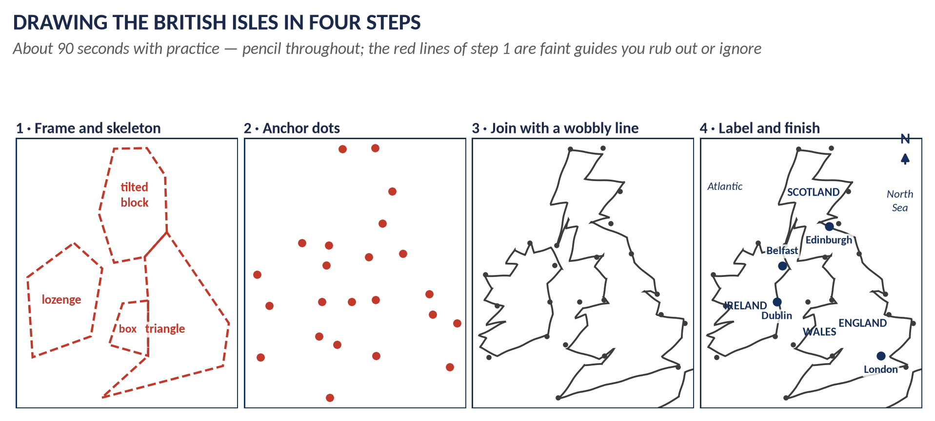
Four base maps (the British Isles, Ireland, Europe, the World), twelve symbols, three sizes, and a four-minute routine — enough to put a good map into any British History answer. Taught from zero: no drawing skill is needed.
Read once, then practise fifteen minutes a day for ten days
Contents
HOW TO USE THIS · Updating the contents
Right-click the contents → Update Field → Update entire table, before saving as PDF.

How to Use This Guide 3
The one idea behind everything 3
What this guide gives you 3
Part One — Why Maps Score 4
What the examiner sees 4
When a map helps — and when it wastes time 4
Part Two — How Many, How Big, How Long 6
How many maps in the whole paper 6
How big 6
How long 7
Where on the page 7
Your tools 8
Part Three — The Symbol Kit 9
The anatomy of a finished map 10
Part Four — The Four Base Maps 11
Base map 1 · The British Isles 11
Four steps 11
The anchor points 12
Base map 2 · Ireland 13
Base map 3 · Europe 14
Base map 4 · The World 15
The diagram map — for everything else 16
Part Five — Which Map for Which Topic 17
Part Six — Six Worked Examples 18
Worked example 1 · Industrial Britain 18
Worked example 2 · Ireland 19
Worked example 3 · The First World War 20
Worked example 4 · The Napoleonic Wars 21
Worked example 5 · The Empire and its end 22
Worked example 6 · The Second World War 23
Part Seven — The Ten-Day Practice Plan 24
Part Eight — Common Mistakes and the Exam-Day Checklist 25
Twelve common mistakes 25
The exam-day checklist 25

How to Use This Guide

The one idea behind everything
KEY IDEA · The secret of exam maps
You are not drawing an accurate picture of Britain. You are drawing a diagram of your argument with a rough coastline behind it. The examiner does not measure your coast. They look for four things: a frame, a title with dates, clear symbols, and a key. Get those right and a wobbly outline still looks excellent.

In your notes, the maps were printed by a computer. In the exam you will have a pencil, a pen and about four minutes. This guide turns those printed maps into something your hand can reproduce quickly.

What this guide gives you
Part | What you learn
Part One | Why maps score, and when not to draw one.
Part Two | How many maps, how big, how long, and where on the page.
Part Three | The symbol kit: twelve symbols that cover every map.
Part Four | The four base maps — British Isles, Ireland, Europe, World — drawn step by step.
Part Five | Which map for which topic: all ten topics in one table.
Part Six | Six worked examples to copy, each with its drawing order.
Part Seven | A ten-day practice plan.
Part Eight | The common mistakes, and a one-page checklist for exam day.

REMEMBER · How to learn it
Do not just read this guide. Keep a pencil and blank paper beside you. Every time you see a map, draw it — once looking, once from memory. Maps are learned by the hand, not the eye.

Part One — Why Maps Score

What the examiner sees
The CSS examiner reads hundreds of answer scripts. Almost all of them are pages of plain writing. When a page opens with a clean, framed, labelled map, three things happen at once:
1. It stands out. The examiner notices the answer before reading a word of it.
2. It proves knowledge. A map with Culloden, Derby and Prestonpans in the right order shows that you know the events — not just their names.
3. It organises the answer. Numbers on the map (①, ②, ③) can match the headings of your answer, so the examiner sees your plan in one glance.
WHAT THE EXAMINER HAS ASKED · The honest truth about marks
No mark scheme prints "2 marks for a map". A map earns marks indirectly: it improves presentation, shows precise knowledge, and makes a borderline answer look like a strong one. A map never replaces writing. A beautiful map with a thin answer still scores a thin mark; a strong answer with a map scores at the top of its band.

When a map helps — and when it wastes time
A map is worth drawing only when place matters to the question.
Draw a map when the question is about… | Do not draw a map when the question is about…
Wars and battles — Spanish Succession, Seven Years War, Napoleon, Crimea, the World Wars, the Falklands | Ideas and parties — Whigs and Tories, Chartism's aims, Thatcherism, New Labour
Empire — expansion, the Scramble for Africa, India, decolonisation | Constitutional change — the Bill of Rights, Cabinet government, Parliament Acts
Ireland — plantation, Union, Famine, Home Rule, partition, the Troubles | Personalities — "Assess Peel", "Evaluate Gladstone"
Industry and towns — the Industrial Revolution, railways, the 1832 Reform Act's new towns | Social reform — Poor Law, factory acts, the welfare state (a chart or flow diagram is better)
Rebellions and routes — 1688, 1715, 1745, 1798 | Economic policy — free trade, monetarism (use a table or timeline)
Devolution and Brexit — the four nations, Remain and Leave areas | Comparisons of two people (use a two-column table)

TRAP — DO NOT FALL INTO IT · Do not force a map
A map on a question about Walpole's financial policy looks like padding and costs four minutes you need for writing. If place does not matter, draw a mind map, timeline or table instead — they score the same way.

Part Two — How Many, How Big, How Long

How many maps in the whole paper
In Part II you write four answers in 2 hours 30 minutes — about 35 minutes each.
KEY IDEA · The rule
Two or three maps in the whole paper. Never more than one map per answer. Four is the absolute maximum, and only if all four questions are about wars, empire or Ireland.

Your four questions | Maps to draw
All four are about ideas, parties, reform | None — use mind maps and tables instead
One question is a war, empire or Ireland question | One map, in that answer
Two or three questions are place-based | Two or three maps, one each
Short notes (Q8) | Usually none. At most a tiny sketch (5 × 5 cm) for a note such as the Falklands or Suez

How big
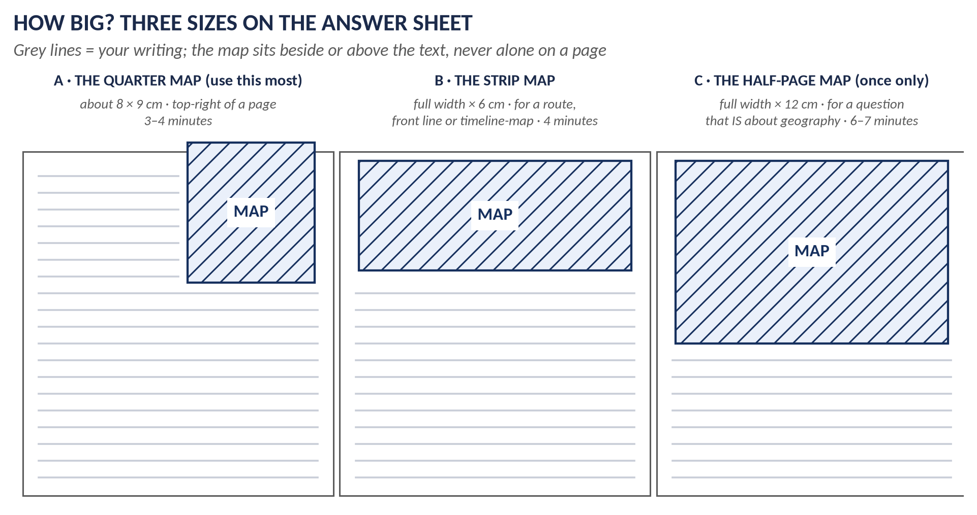
Figure 1 · Three sizes of map on the answer sheet.
Size | Measurements | Use it for
A · Quarter map | about 8 × 9 cm, top-right of the page, writing beside it | Most maps. Battles, Ireland, industry, a rebellion. This is your standard.
B · Strip map | full width × 6 cm | A route (the route to India, the Jacobite march), a front line, or a map with a timeline under it.
C · Half-page map | full width × 12 cm | Only once in the paper, and only for a question that is itself about geography — "the growth of the Empire", "Britain and the Scramble for Africa".

REMEMBER · The size rule in one line
Big enough to label clearly, small enough to leave room for writing. If you cannot fit six labels without crowding, it is too small; if it takes more than four minutes, it is too big.

How long
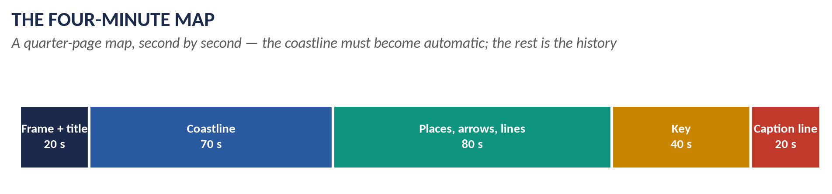
Figure 2 · The four-minute map.
- Frame and title — 20 seconds. Rule a box; write the title and dates inside it.
- Coastline — about 70 seconds. This is the only part that needs practice. After ten days of drilling it becomes automatic.
- Places, arrows and lines — about 80 seconds. This is the history: dots, crosses, numbers, arrows.
- Key — 40 seconds. Every symbol, explained.
- Caption — 20 seconds. One sentence under the map linking it to your argument.
WHAT THE EXAMINER HAS ASKED · Total map time in the paper
Two or three maps × four minutes = 8 to 12 minutes out of 150. That is affordable. More than that starts to eat your writing — and writing is where most of the marks are.

Where on the page
1. Write your introduction first (thesis in one or two sentences).
2. Draw the map straight after the introduction, at the top of the first full page of the answer, usually top-right, with your first heading beginning beside it.
3. Refer to it in the text: "(see Map 1, ②)". A map the text never mentions looks like decoration.
4. Number your maps across the paper: Map 1, Map 2, Map 3.

Your tools
Tool | How to use it
Pencil (HB or 2B) | For the coastline and hatching. Soft enough to be clear, easy to correct.
Your pen | For labels, numbers, title and key — ink reads better and looks finished.
Ruler | For the frame and the key box only. Never rule a coastline.
Eraser | For small corrections only. Do not waste time perfecting.
Colours | Not needed. Hatching (////) and dots (....) do the work of colour. If you use colour at all, use one, for the most important thing only.

NOTE · Check the paper's instructions
Always follow any instruction printed on the answer book about pencils or colours. Most candidates draw the outline in pencil and write labels in the same blue or black pen they write the answer with.

Part Three — The Symbol Kit
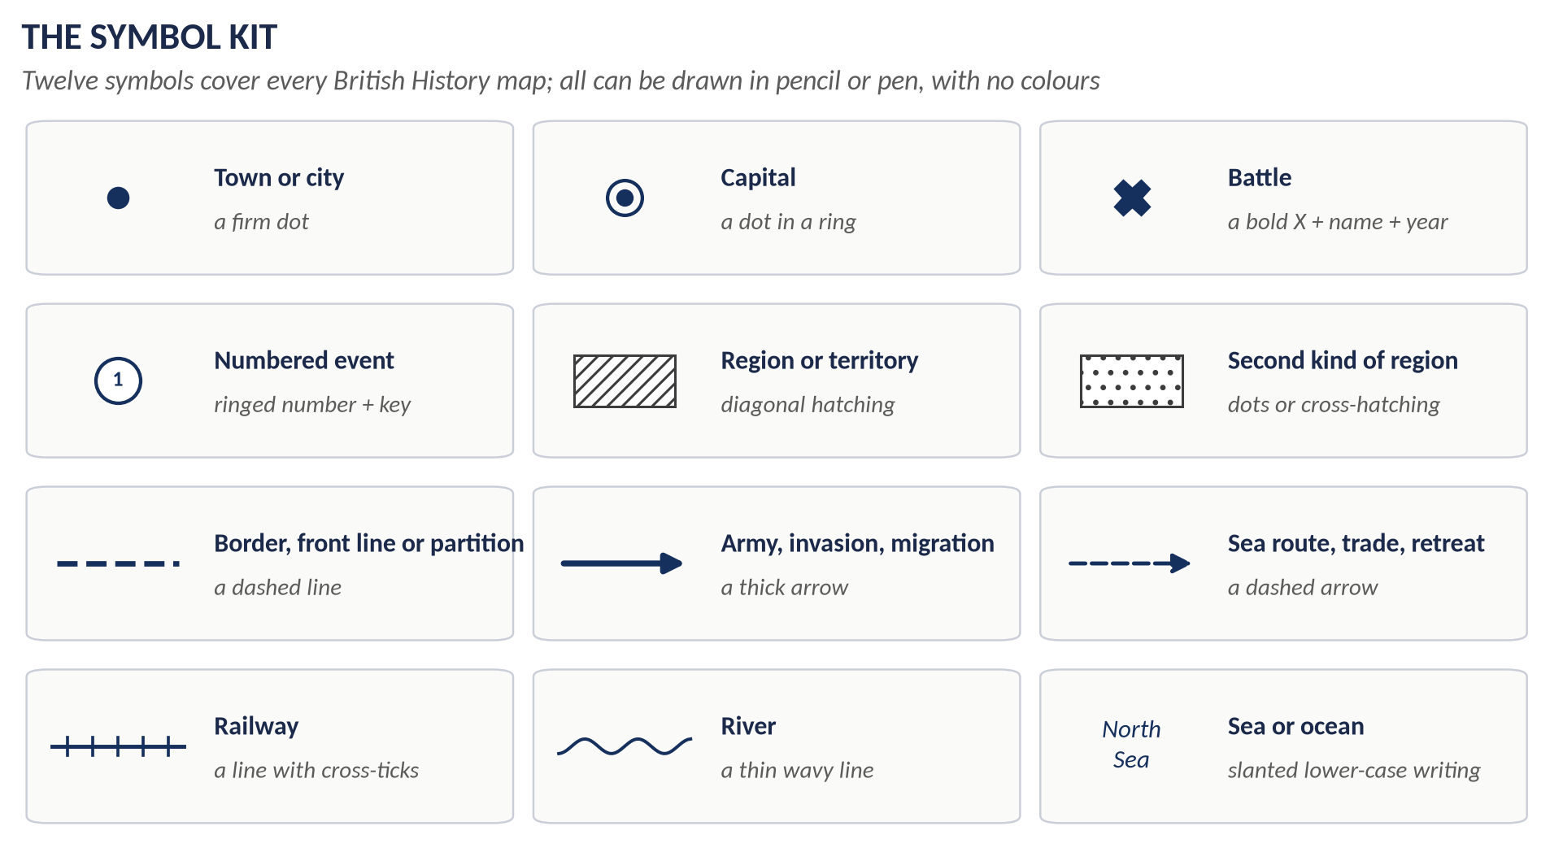
Figure 3 · The twelve symbols.
KEY IDEA · Four rules for symbols
1. Same symbol, same meaning, in every map you draw — the examiner learns your language once.
2. Numbers keep a map clean. Instead of writing "Glenfinnan: Prince Charles raises his standard, August 1745" on the map, write ① on the map and the words in the key.
3. Every battle gets a name and a year: ✕ Culloden 1746.
4. Hatching instead of colour: diagonal lines (////) for the main area, dots (....) for a second area, cross-hatching for a third.

The anatomy of a finished map
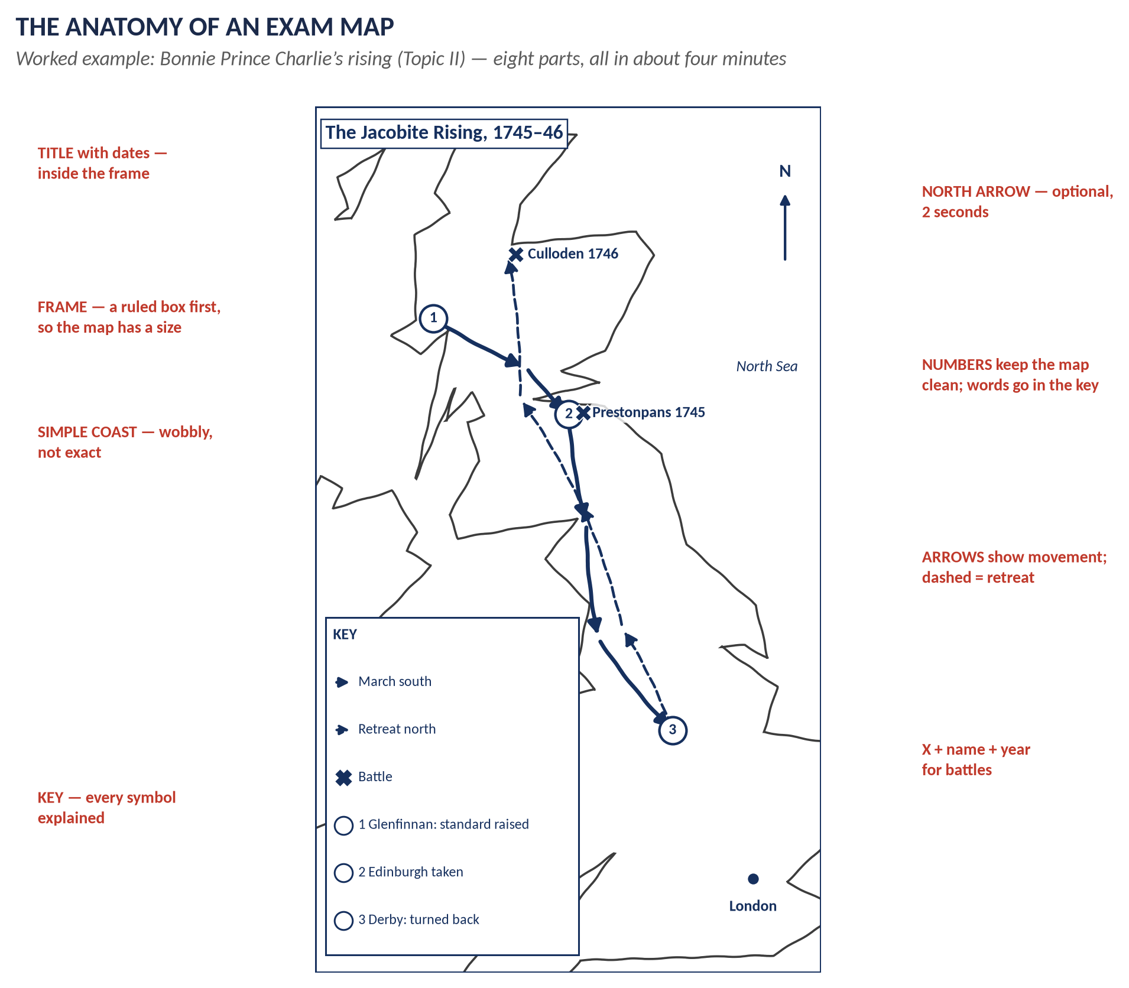
Figure 4 · The eight parts of an exam map, on the Jacobite rising of 1745–46.
Part | Why it matters
1 Frame | A ruled box fixes the size before you start, and makes even a rough sketch look deliberate.
2 Title with dates | "The Jacobite Rising, 1745–46" — the title tells the examiner what the map proves.
3 Simple coastline | Wobbly, not exact. Recognisable shape is enough.
4 Places | Dots for towns, ✕ for battles — only the places your answer uses.
5 Movement | Arrows for armies; dashed arrows for retreats and sea routes.
6 Numbers | ①②③ for events, explained in the key, in the order your answer discusses them.
7 Key | Explains every symbol and number. A map without a key is only half a map.
8 North arrow | Optional; two seconds. It makes the map look finished.

Part Four — The Four Base Maps
KEY IDEA · You only need four
Almost every map in British History is drawn on one of four bases:
1. The British Isles — the most used: rebellions, industry, reform, devolution, Brexit.
2. Ireland — a zoom of the Isles: the Boyne, 1798, the Famine, Home Rule, partition, the Troubles.
3. Europe — the wars from Louis XIV to Hitler, the Crimea, the Cold War, the EU.
4. The World — the Empire, its growth and its end.
Master these four and you can draw any map in the syllabus. For anything else, use the diagram map (at the end of this Part).

Base map 1 · The British Isles

Four steps
Figure 5 · Drawing the British Isles in four steps.
1. Frame and skeleton. Rule the frame. Very faintly, draw four simple shapes: a triangle for England (Land's End, Dover, and a point at the Scottish border), a small box on its west side for Wales, a tilted block above for Scotland, and a lozenge (a squashed diamond) to the left for Ireland.
2. Anchor dots. Put in the anchor points (next page) as small dots.
3. Join the dots with a slightly wobbly line. Do not try to show every bay — three or four bumps per side are plenty.
4. Label and finish: the four names, the capitals, the seas, a north arrow.

The anchor points
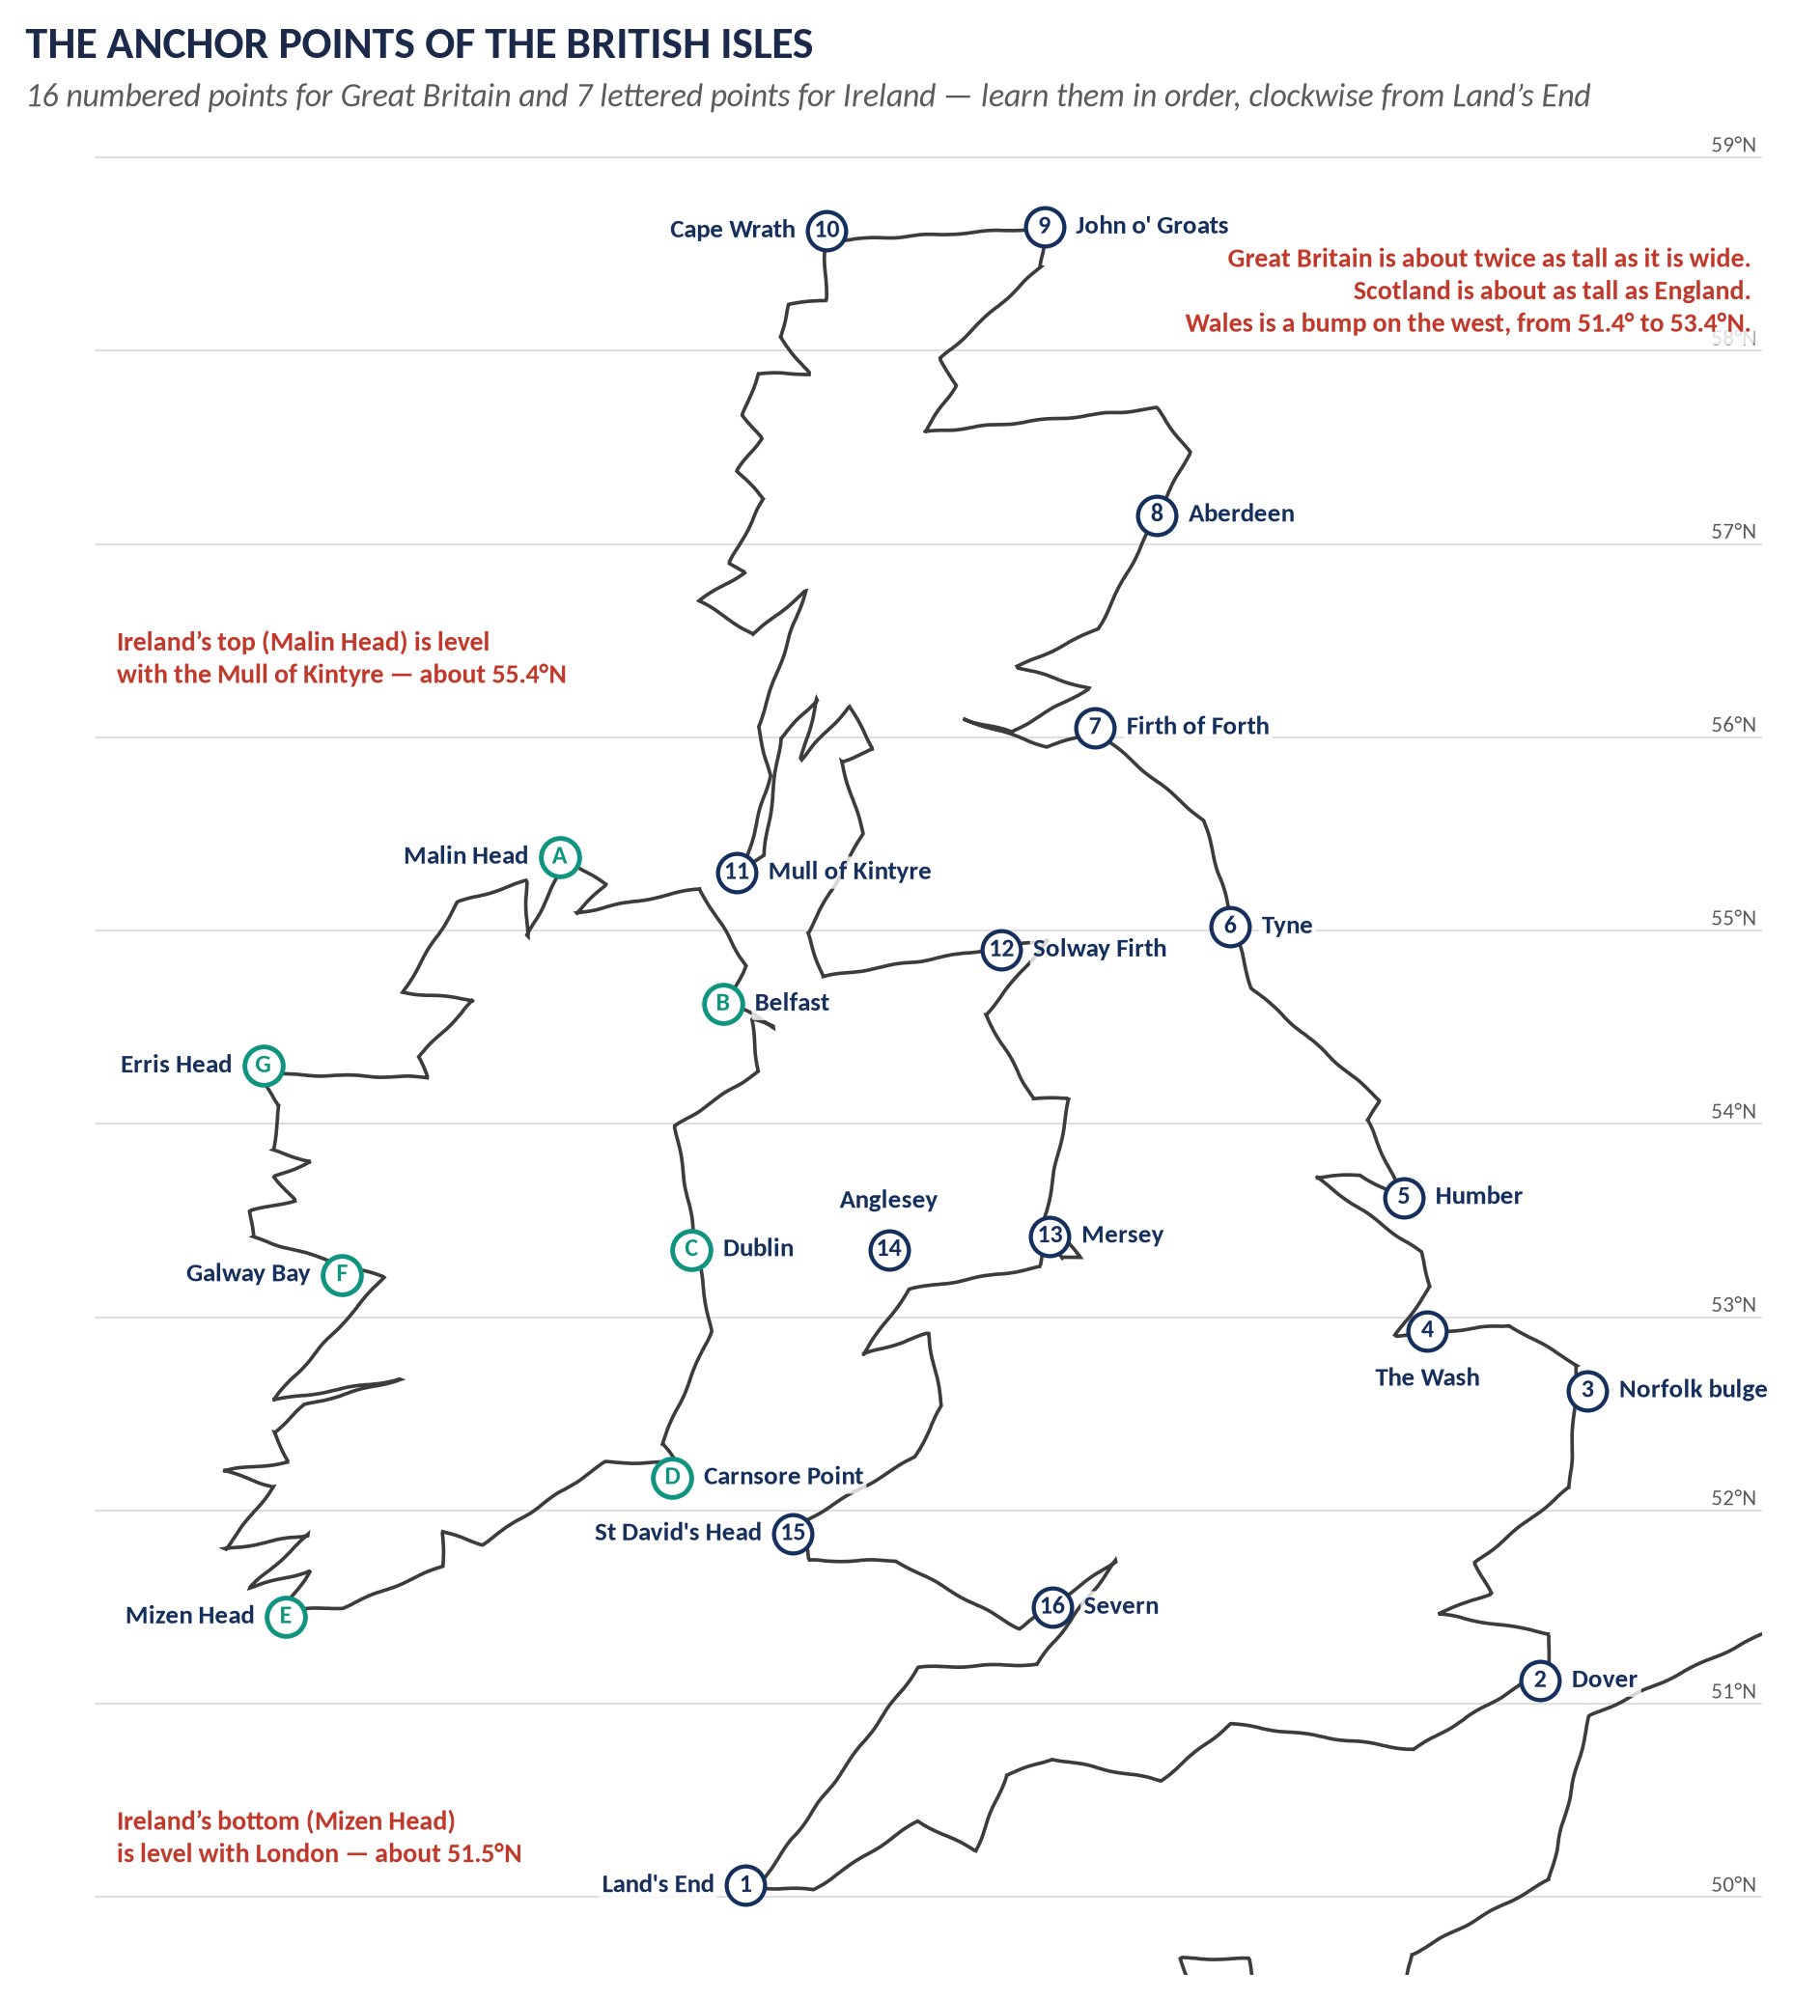
Figure 6 · The sixteen anchor points of Great Britain and seven of Ireland.
Learn the anchors in order, clockwise from Land's End: Land's End → Dover → the Norfolk bulge → the Wash → the Humber → the Tyne → the Firth of Forth → Aberdeen → John o' Groats → Cape Wrath → Mull of Kintyre → Solway Firth → Mersey → Anglesey → St David's Head → Severn, and back to Land's End.
REMEMBER · Four proportion rules
1. Great Britain is about twice as tall as it is wide.
2. Scotland is about as tall as England.
3. Wales is a bump on the west side, between the Severn and the Mersey.
4. Ireland hangs to the left: its bottom (Mizen Head) is level with London; its top (Malin Head) is level with the Mull of Kintyre.

HOW TO USE THIS · The two "bites" out of the east coast
The east coast has two bites that make Britain recognisable: the Wash (a square bite between Norfolk and Lincolnshire) and the Firth of Forth (a narrow bite, with Edinburgh at its inner end). On the west, the Bristol Channel (between Wales and Devon) and the Solway (between England and Scotland) are the two to show. With these four bites, any examiner recognises the shape at once.

Base map 2 · Ireland
Ireland is the easiest shape in the syllabus: a lozenge with a ragged west coast and a smooth east coast.
1. Draw the lozenge: Malin Head at the top, Belfast at the top-right, Dublin in the middle of the east side, Carnsore Point at the bottom-right, Mizen Head at the bottom-left.
2. Make the west coast jagged (Galway Bay, Mayo, Donegal) and the east coast smooth.
3. Mark Dublin, Belfast, Cork and Derry — these four towns are enough for almost every Irish question.
4. For partition questions, hatch the north-east corner: Northern Ireland is roughly the top-right quarter of the island.
REMEMBER · The four provinces — one line each
Ulster = north (with Belfast and Derry) · Leinster = east (with Dublin) · Munster = south (with Cork) · Connacht = west (the poorest, worst hit by the Famine).

Base map 3 · Europe
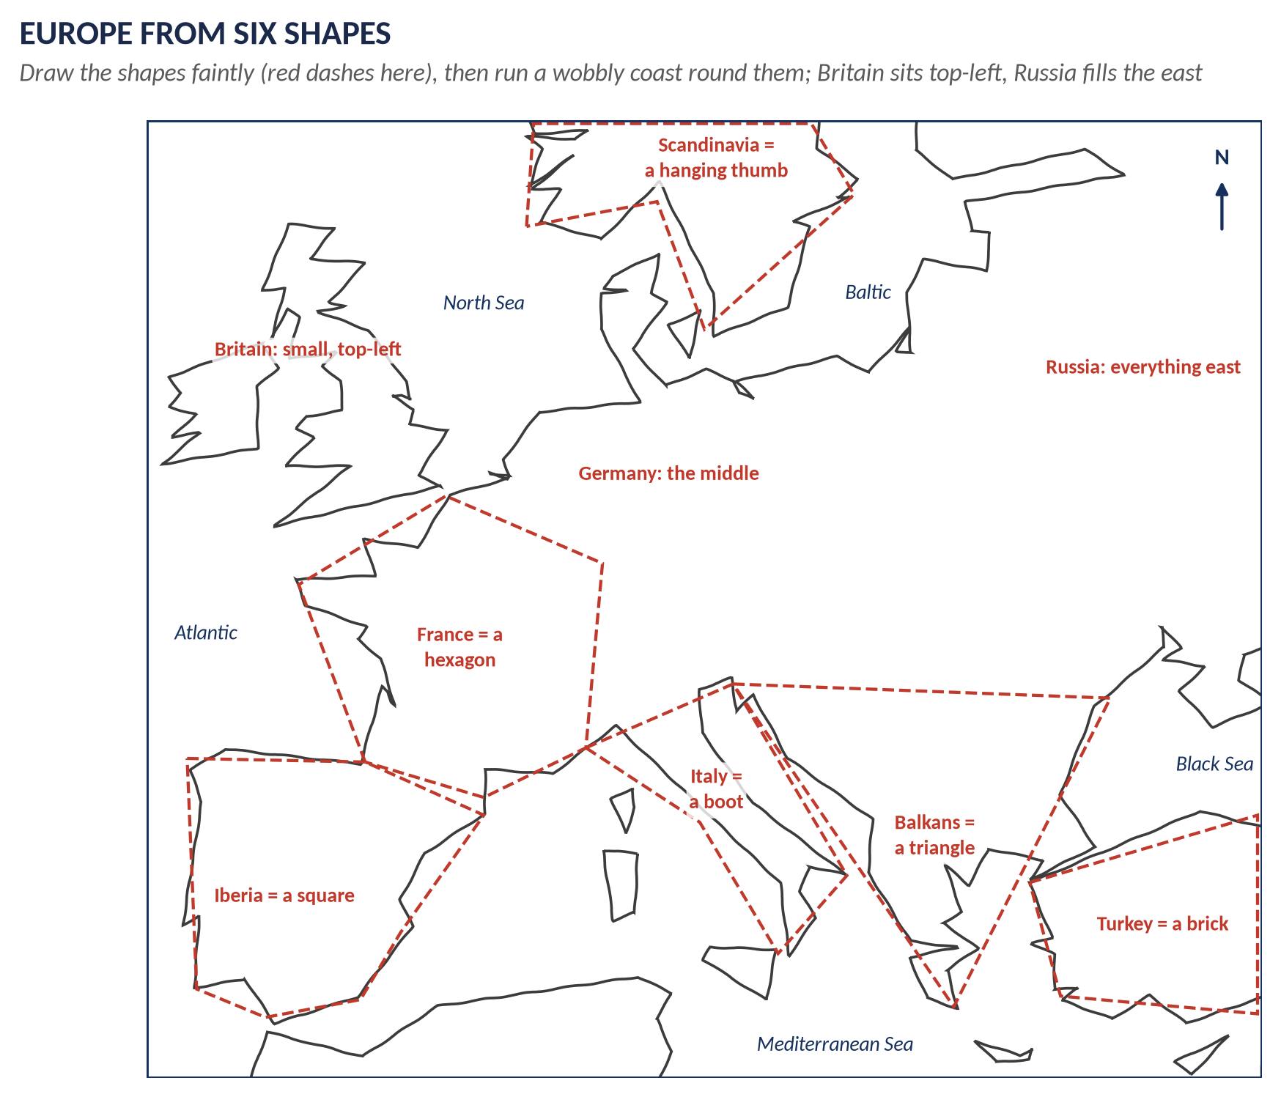
Figure 7 · Europe built from six simple shapes.
Draw Europe from six shapes, then run a wobbly coast round them:
Shape | How to draw it
Iberia (Spain and Portugal) | A square, bottom-left. Gibraltar is its bottom corner.
France | A hexagon above Iberia; the Channel coast faces Britain.
Italy | A boot hanging into the Mediterranean, toe towards Sicily.
The Balkans | A triangle pointing down to Greece.
Scandinavia | A hanging thumb at the top, with Denmark as a small stub below it.
Turkey | A brick at the bottom-right, with the Black Sea above it.

Then add: Britain small, top-left; Germany in the middle (between France and Poland, with no strong natural edge); Russia filling everything east.
HOW TO USE THIS · Zoom in, do not draw the whole continent
You rarely need all of Europe. For the Western Front draw only Britain, France, Belgium and Germany. For the Peninsular War, only Iberia and France. For the Crimea, only the Black Sea and Turkey. A smaller area means bigger, clearer labels.

Base map 4 · The World
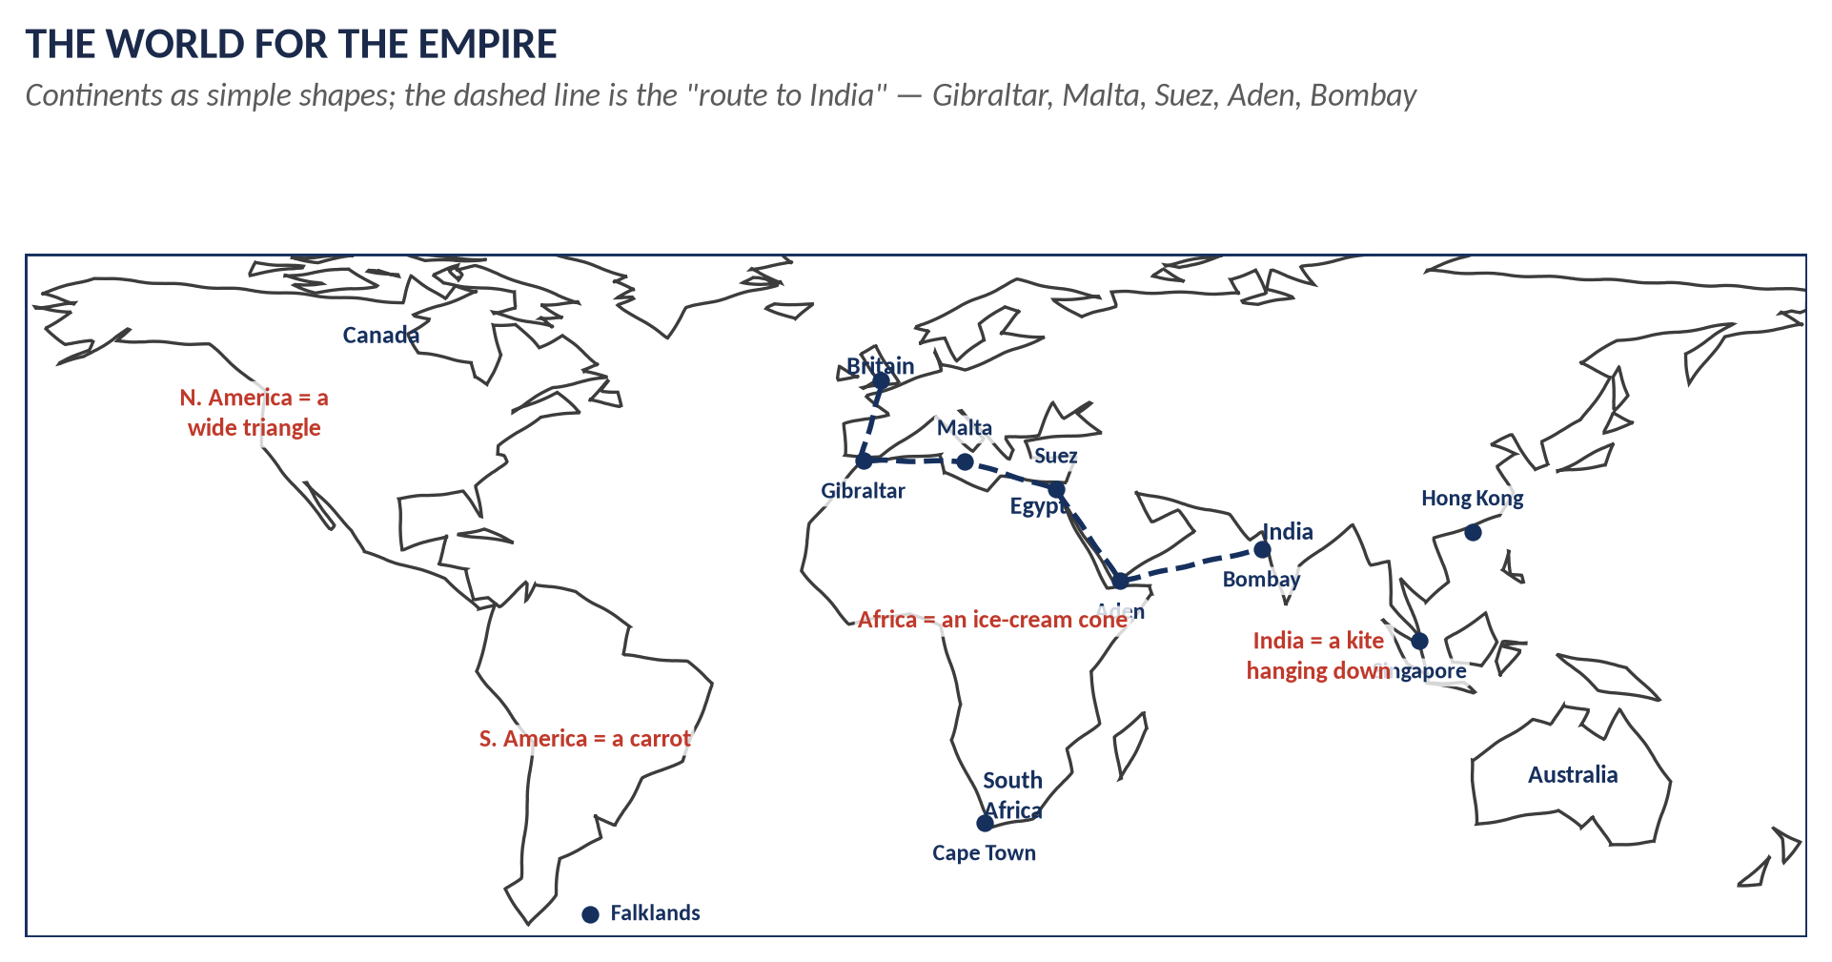
Figure 8 · The world for Empire questions.
Continent | Simple shape
North America | A wide triangle, point down to Mexico; Canada is the top half.
South America | A carrot, point down.
Africa | An ice-cream cone: a round top (the bulge of West Africa) and a point at the Cape.
Europe and Asia | One long band across the top; India is a kite hanging down from its middle.
Australia | A rough rectangle, bottom-right.

KEY IDEA · The route to India — the spine of every Empire map
Britain → Gibraltar → Malta → Suez (after 1869) → Aden → Bombay. Before 1869 the route went round the Cape of Good Hope. Draw this as a dashed line and you have explained why Britain cared about Egypt, the Mediterranean and South Africa.

The diagram map — for everything else
Some places are too awkward to draw: the Falklands, the Crimea, Suez, the Balkans. Do not try to draw their real shape. Draw a diagram map: simple boxes, blobs and arrows, clearly labelled.
Example | The diagram map
The Falklands, 1982 | A vertical line on the left for the coast of Argentina; two blobs on the right for the islands; a circle round them marked "200-mile exclusion zone"; a long arrow from the top marked "Task Force from Britain via Ascension"; ✕ Goose Green, ● Port Stanley — surrender 14 June 1982.
The Crimea, 1854–56 | A big oval for the Black Sea; a diamond hanging into it for the Crimea; ● Sevastopol at its tip; ✕ Alma, Balaklava, Inkerman; ● Constantinople at the bottom-left corner of the sea.
Suez, 1956 | A vertical canal line from the Mediterranean to the Red Sea; Egypt to the left, Sinai to the right; arrows: Israel from the east (29 Oct), Britain and France from the sea at Port Said (5–6 Nov).

WHAT THE EXAMINER HAS ASKED · A diagram map is still a map
The examiner rewards clarity and accuracy of places and events, not artistic skill. A neat diagram map with correct names and dates scores as well as a real outline.

Part Five — Which Map for Which Topic
This table tells you, for each topic, which base map to use and what to put on it. Learn the places in bold; they are the ones examiners expect.
Topic | Base map | What to mark | Size
I · 1685–1714 | Isles; Europe | Torbay 1688 (William lands) → London; Boyne 1690, Limerick 1691; Killiecrankie 1689, Glencoe 1692. War of Spanish Succession: Blenheim 1704, Ramillies 1706, Gibraltar 1704, Utrecht 1713. | Quarter
II · 1714–1783 | Isles; World | Jacobites: 1715 and the 1745 march (Glenfinnan → Edinburgh → Derby → Culloden 1746). Seven Years War: Quebec 1759, Plassey 1757, Quiberon Bay 1759. America: the 13 colonies as a strip, Saratoga 1777, Yorktown 1781. | Quarter / strip
III · 1783–1815 | Europe; Ireland | Nile 1798, Copenhagen 1801, Trafalgar 1805, the Peninsula from Lisbon, Waterloo 1815, the blockade. Ireland 1798: Vinegar Hill, the French at Killala; the Union 1800/01. | Quarter
IV · Industry | Isles | Coalfields (hatched), cotton (Lancashire), wool (Yorkshire), iron and steel (Black Country, Sheffield), ports (Liverpool, Glasgow); Bridgewater Canal 1761; railways 1825, 1830, 1838. | Quarter
V · Reform and Ireland | Isles; Ireland | 1832: new towns without MPs (Manchester, Birmingham, Leeds) vs rotten boroughs (Old Sarum); Chartist Newport 1839. Ireland: Famine in the west, Ulster against Home Rule. | Quarter
VI · Victorian world | Europe; World | Crimea; the Eastern Question (Constantinople, the Straits, Cyprus 1878); India 1857 (Meerut, Delhi, Cawnpore, Lucknow); Africa: Egypt 1882, Suez 1869, Fashoda 1898, the Boer War 1899–1902, "Cape to Cairo". | Quarter / half
VII · 1901–1939 | Europe; Ireland | Western Front, Somme, Ypres, Gallipoli, Jutland; Ireland 1916–22 and partition; appeasement: Rhineland 1936, Austria 1938, Sudetenland (Munich) 1938, Prague 1939, Poland 1939. | Quarter
VIII · 1939–1979 | Europe; World | Dunkirk, Battle of Britain, El Alamein, D-Day; the Iron Curtain "from Stettin to Trieste", Berlin; decolonisation dates; Suez 1956 (diagram map). | Quarter / half
IX · 1979–1997 | Diagram; Europe; Isles | Falklands (diagram map); the EEC/EU, Britain joining 1973; Northern Ireland and the Anglo-Irish Agreement 1985. | Quarter / small
X · 1997–2026 | Isles; World | Devolution: Scottish Parliament and Welsh Assembly 1999, NI Assembly 1998; Brexit 2016: Scotland (62%) and Northern Ireland (56%) Remain, England and Wales Leave; Afghanistan 2001, Iraq 2003. | Quarter

REMEMBER · Five maps cover most of the syllabus
If you practise only five maps, make them these: (1) the 1745 Jacobite rising, (2) Industrial Britain, (3) Ireland: Boyne to partition, (4) Europe at war (Napoleon / 1914 / 1939 — the same base), and (5) the Empire and the route to India. They are the six worked examples in Part Six.

Part Six — Six Worked Examples
Each example shows the finished map, then the drawing order. Copy each one three times: once looking, twice from memory.

Worked example 1 · Industrial Britain
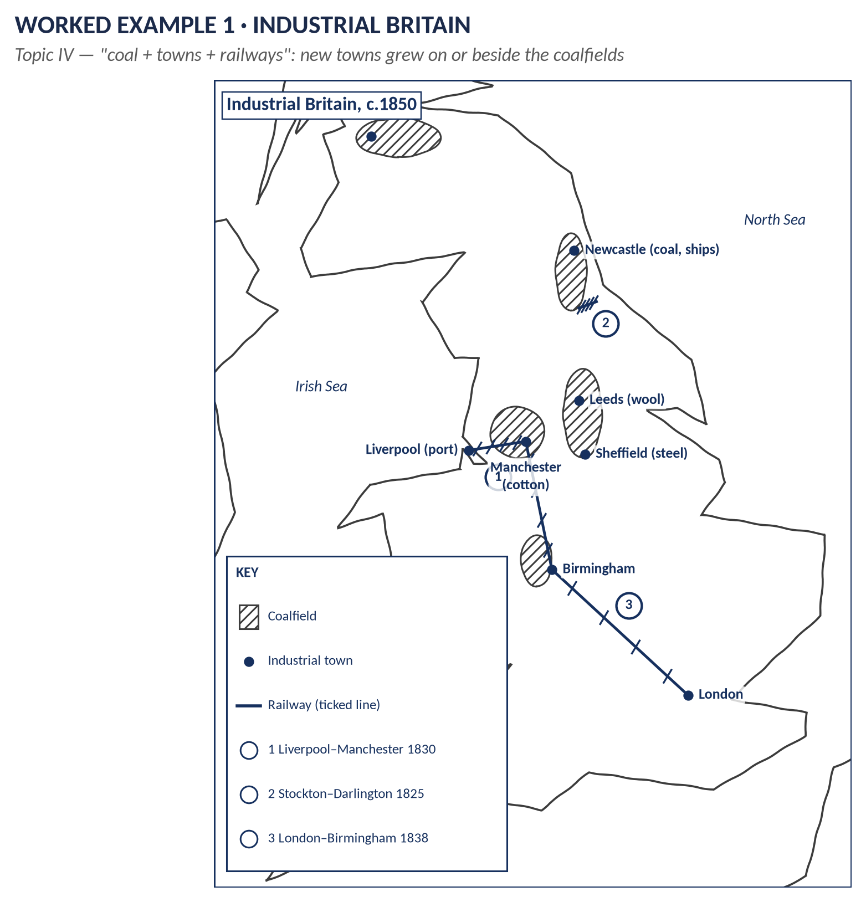
Figure 9 · Industrial Britain, c.1850.
Drawing order:
1. Frame and title: Industrial Britain, c.1850.
2. England, Wales and southern Scotland only — no need for the Highlands or Ireland.
3. Six hatched coalfields: South Wales, the Midlands, Lancashire, Yorkshire, the North-East, central Scotland.
4. Towns on or beside the coalfields, with their industry in brackets: Manchester (cotton), Leeds (wool), Sheffield (steel), Newcastle (coal, ships), Birmingham, Glasgow; the ports Liverpool and London.
5. Three railways as ticked lines, with numbers ①②③ and dates in the key.
VERDICT · What this map proves
Industry went where the coal was. New towns grew on the coalfields of the north and Midlands — which is also why, in Topic V, those towns demanded MPs in 1832. One map, two topics.

Worked example 2 · Ireland
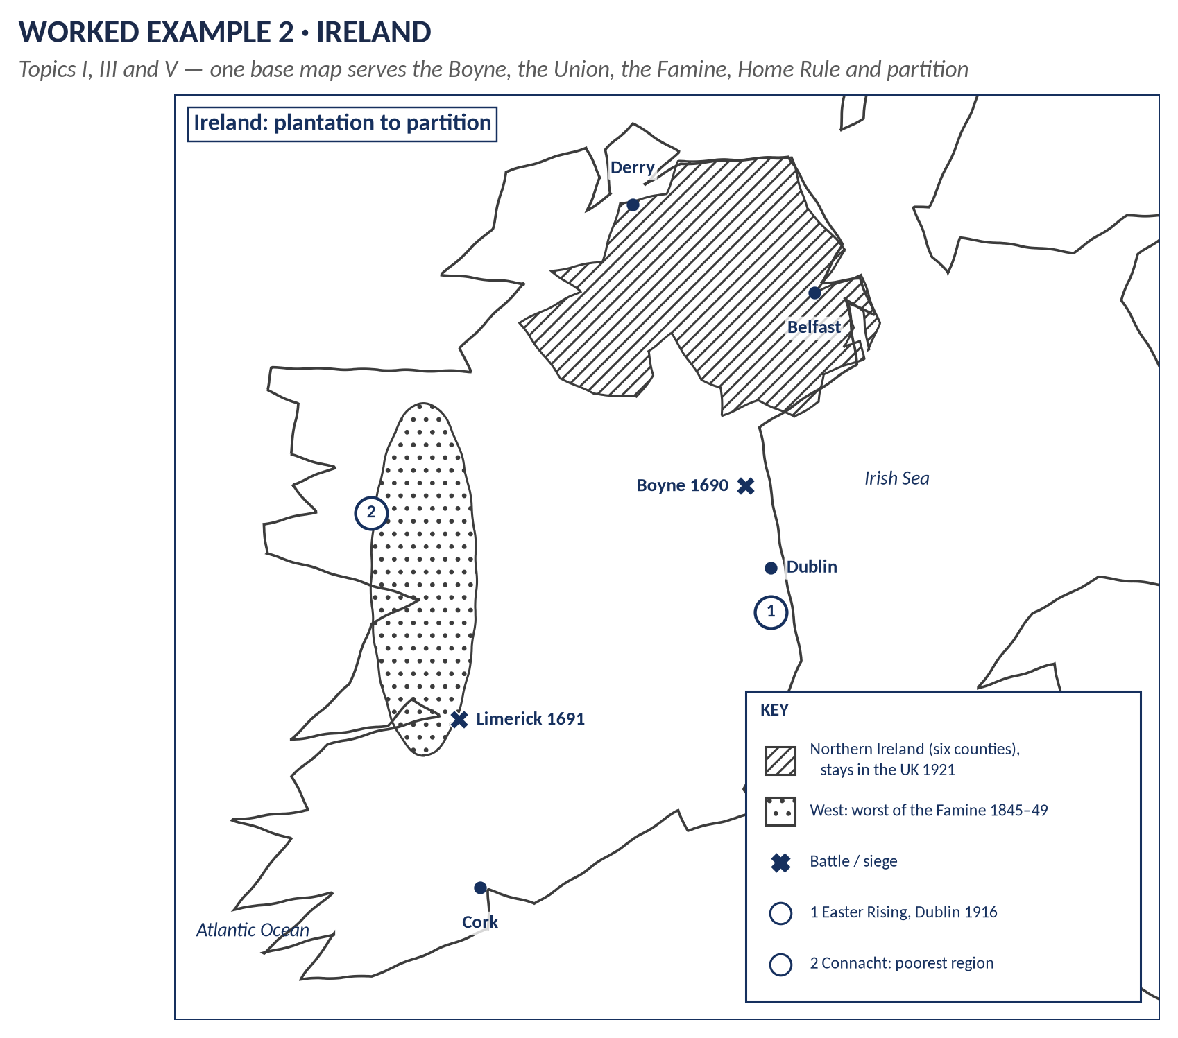
Figure 10 · Ireland from plantation to partition.
Drawing order:
1. The lozenge, jagged west, smooth east.
2. Four towns: Dublin, Belfast, Cork, Derry.
3. ✕ Boyne 1690 (north of Dublin) and ✕ Limerick 1691 (west).
4. Hatch the north-east for Northern Ireland; dots in the west for the Famine.
5. Numbers for events (① Easter Rising 1916 in Dublin).
HOW TO USE THIS · One base, five questions
The same Irish outline answers questions on William III (Topic I), the 1798 rising and the Union (Topic III), the Famine and Home Rule (Topic V), 1916–22 and partition (Topic VII) and the Troubles (Topics VIII–X). Change only what you put on it.

Worked example 3 · The First World War
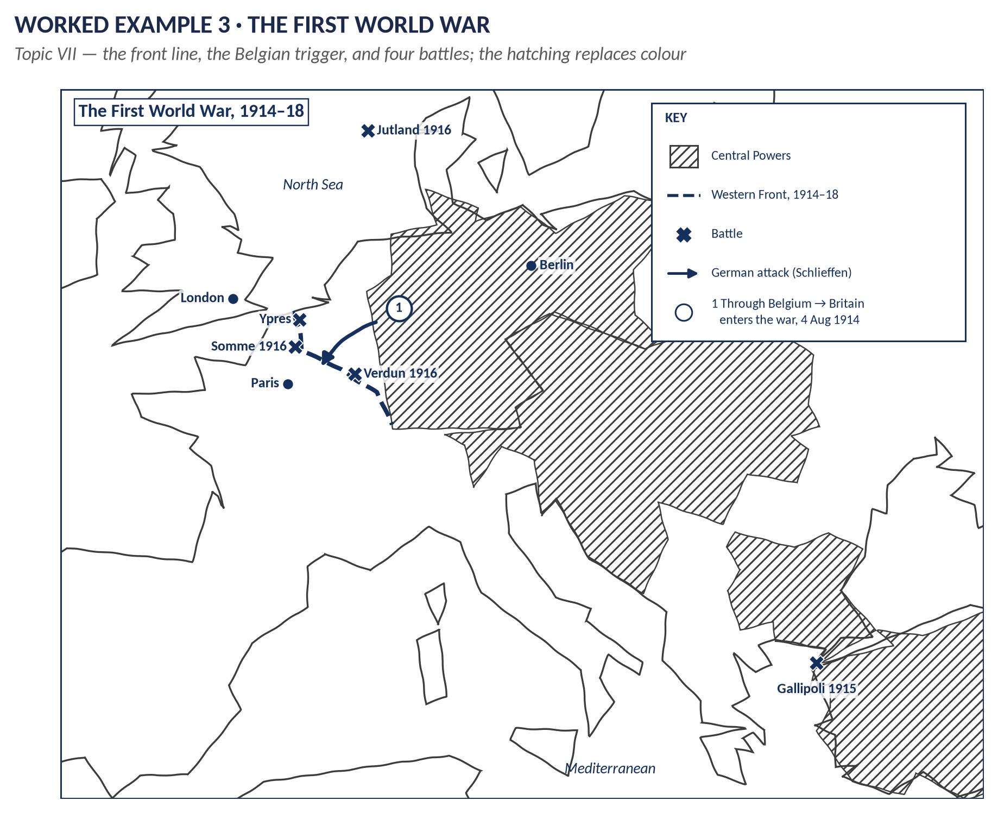
Figure 11 · The First World War.
Drawing order:
1. Zoomed Europe: Britain, France, Belgium, Germany, down to the Mediterranean.
2. Hatch the Central Powers (Germany, Austria-Hungary, the Ottoman Empire, Bulgaria).
3. The Western Front as a thick dashed line from the Belgian coast to Switzerland.
4. ✕ Ypres, Somme 1916, Verdun 1916, Gallipoli 1915, Jutland 1916 (in the North Sea).
5. An arrow through Belgium — the reason Britain entered the war on 4 August 1914.

Worked example 4 · The Napoleonic Wars
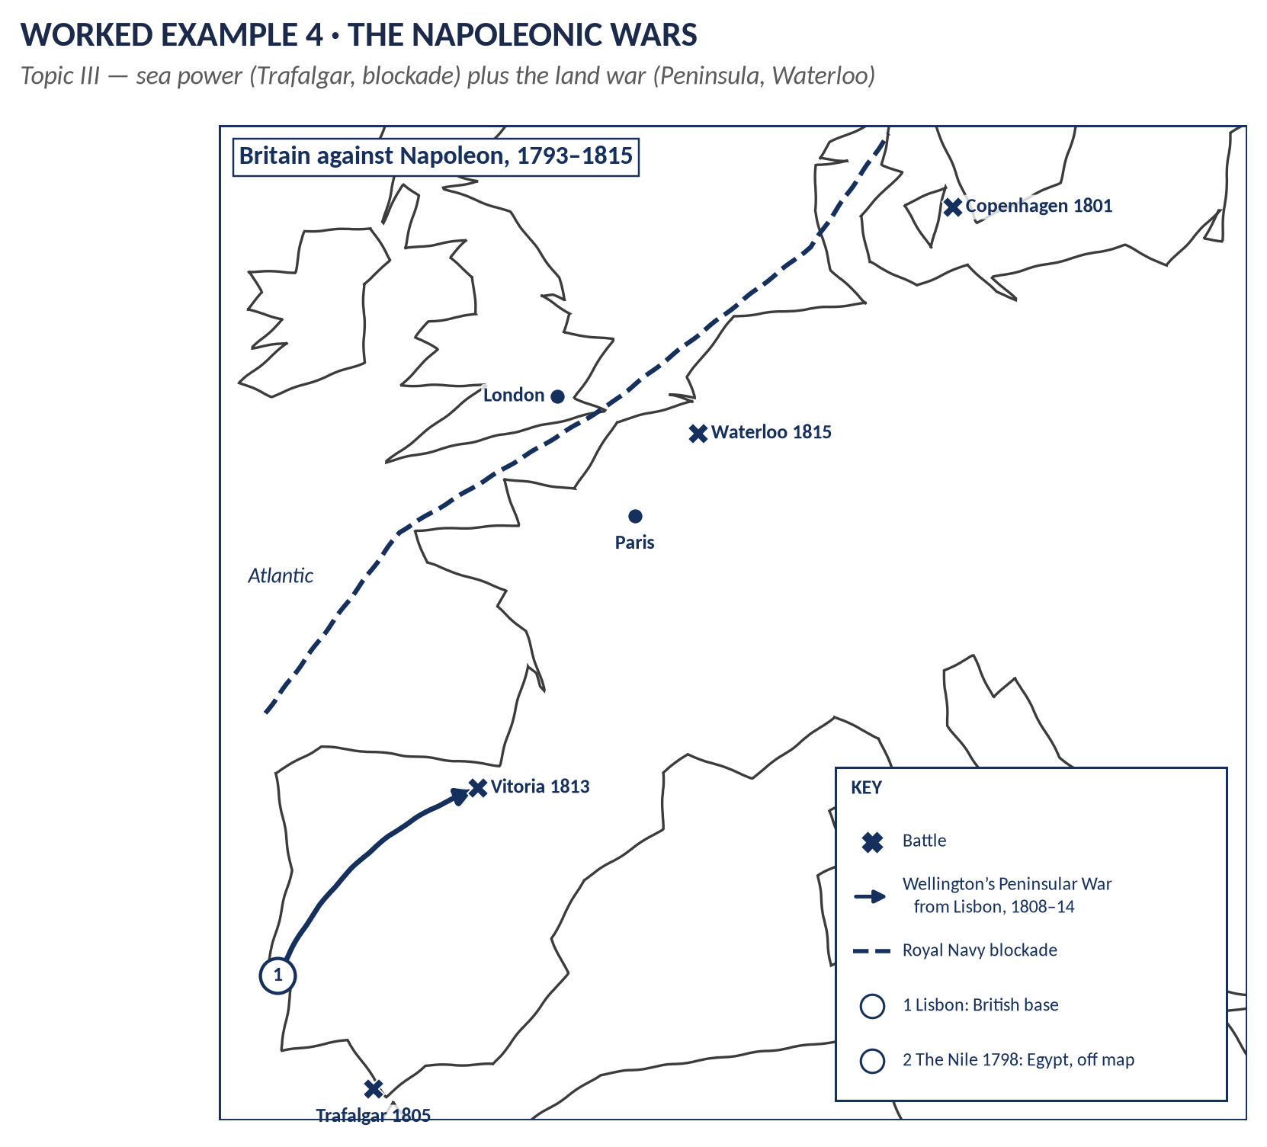
Figure 12 · Britain against Napoleon.
Drawing order:
1. Western Europe: Iberia, France, the Low Countries, Britain, Denmark.
2. Sea battles: ✕ Copenhagen 1801, ✕ Trafalgar 1805 (off south-west Spain); a note for the Nile 1798.
3. The blockade as a dashed line along the coast.
4. The Peninsular War: an arrow from Lisbon to Vitoria 1813.
5. ✕ Waterloo 1815 in Belgium.
VERDICT · What this map proves
Britain beat Napoleon with sea power (Trafalgar, the blockade) and a long war of attrition on land (the Peninsula), then the final blow at Waterloo. The map shows both halves of that argument.

Worked example 5 · The Empire and its end
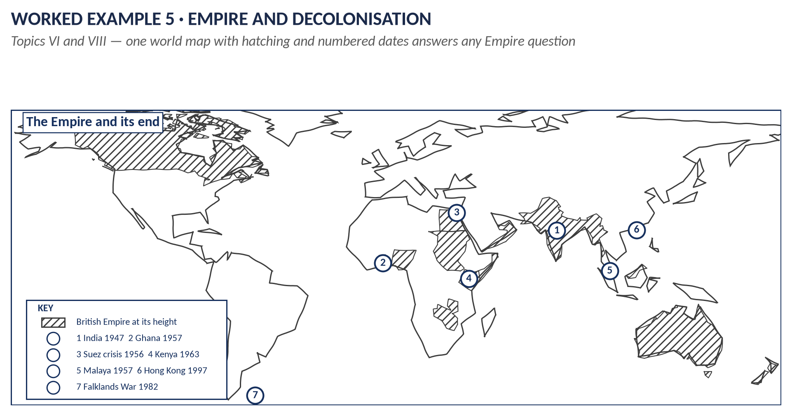
Figure 13 · The Empire and decolonisation.
Drawing order:
1. The world from simple shapes (Part Four).
2. Hatch the main British territories: Canada, India, Australia, New Zealand, South Africa, Egypt and the Sudan, Nigeria, Kenya.
3. Numbers for decolonisation, in date order: India 1947, Suez crisis 1956, Ghana and Malaya 1957, Kenya 1963, the Falklands 1982, Hong Kong 1997.
4. Optional: the route to India as a dashed line.

Worked example 6 · The Second World War
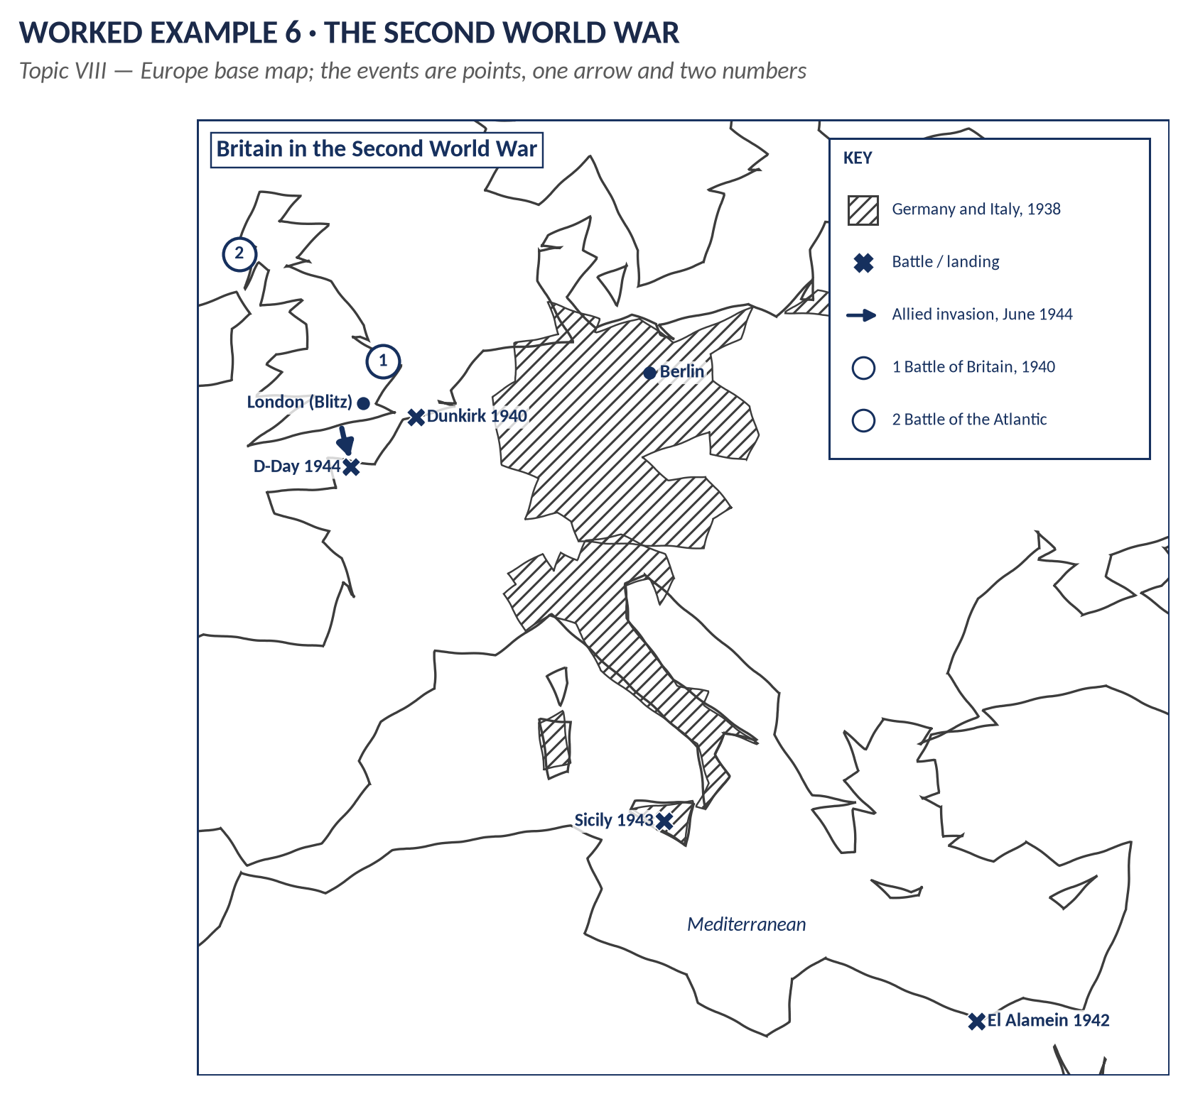
Figure 14 · Britain in the Second World War.
Drawing order:
1. Europe and North Africa.
2. Hatch Germany and Italy.
3. ✕ Dunkirk 1940, ✕ El Alamein 1942, ✕ Sicily 1943, ✕ D-Day 1944 with an arrow from southern England to Normandy.
4. Numbers: ① Battle of Britain 1940 over southern England, ② Battle of the Atlantic to the west.
5. ● London (the Blitz).

Part Seven — The Ten-Day Practice Plan
Fifteen minutes a day. Blank paper and a pencil. Time yourself.
Day | Practise | Target
1 | British Isles: the skeleton shapes and the 16 anchors, looking at Part Four. Draw it five times. | Recognisable shape
2 | British Isles from memory, three times. Check against the anchors map. | Under 2 minutes
3 | Ireland from memory, plus the four towns and four provinces. | Under 1 minute
4 | Europe from the six shapes, three times. | Under 2 minutes
5 | The world from the continent shapes, plus the route to India. | Under 2 minutes
6 | Worked examples 1 and 2 (Industry, Ireland) from memory. | 4 minutes each
7 | Worked examples 3 and 4 (First World War, Napoleon). | 4 minutes each
8 | Worked examples 5 and 6 (Empire, Second World War), plus the Jacobite map. | 4 minutes each
9 | The three diagram maps: Falklands, Crimea, Suez. | 2 minutes each
10 | Mock: take any past question from your QA documents; write the introduction, then draw its map against the clock. | 4 minutes, key included

REMEMBER · After day 10
Keep the skill alive with one map a week until the exam. Whenever you revise a topic, draw its map from Part Five once.

Part Eight — Common Mistakes and the Exam-Day Checklist

Twelve common mistakes
TRAP — DO NOT FALL INTO IT · Mistakes that cost time or marks
1. No frame. The map spreads over the page and looks careless.
2. No title or no dates. The examiner has to guess what the map is for.
3. No key. Symbols that are not explained mean nothing.
4. Too big. A full-page map that took ten minutes, and a thin answer after it.
5. Too small. Labels squashed together and unreadable.
6. Trying to be accurate. Drawing every bay and island wastes minutes and earns nothing.
7. Too many labels. Mark only the places your answer uses — six to ten items is right.
8. Long sentences on the map. Use numbers and put the words in the key.
9. Wrong place. Culloden in England, Waterloo in France, Trafalgar in the Channel — worse than no map. Draw only what you are sure of.
10. A map the text never mentions. Always write "(see Map 1)".
11. A map for a question about ideas. A map on "Assess Peel's conservatism" is padding.
12. More than one map per answer. One good map beats two rushed ones.

The exam-day checklist
KEY IDEA · Before you draw — ask three questions
1. Does place matter to this question? If not, draw a mind map or table instead.
2. Which base map? Isles, Ireland, Europe, World — or a diagram map.
3. Which six to ten things will my answer use? Only those go on the map.

✓ | The map
☐ | Frame ruled — quarter page unless there is a good reason.
☐ | Title with dates inside the frame; Map 1 / 2 / 3 numbered.
☐ | Coastline in pencil — simple, wobbly, recognisable.
☐ | Places: dots for towns, ✕ + name + year for battles.
☐ | Arrows for movement; dashed lines for fronts, borders, sea routes.
☐ | Hatching for areas — no colours needed.
☐ | Numbers for events, in the order of your headings.
☐ | Key explaining every symbol and number.
☐ | One-line caption linking the map to your argument.
☐ | Referred to in the text: "(see Map 1, ②)".
☐ | Four minutes — then stop and write.

VERDICT · The whole guide in three lines
Two or three maps in the paper, one per answer at most, a quarter page each, four minutes each. Learn four base maps and twelve symbols. A frame, a title with dates, clear places and a key turn a rough pencil sketch into the best-looking answer in the pile.

